**Name Phuspinder Singh**

**ID**

**Title Exam Store**

# Section 1- Project planning and design

## Task 1 - Identify the problem

Method of Talk: Phone call

Date and Time: 25 Oct 2021 9:30 am

Subject: First Discussion about the Website

After Paying greets to each other, I introduce myself to Jonas and He told about himself that he runs this exam store and here he stores multiple Books that he sells and now due to online demand and due Pandemic Time he want to sell his books online as told that in start of Covid-19 he had a great loss and still he is running his business in loss.

And I while taking I make him believe that yes this is absolutely right approach and time make his business online.

## Task 2 - Define and document requirements

Scope of Work

The client’s clear cut scope is to sell the books online and keep the record of stock

Defines the features

To expand his business he want a software that could come top of search list on when user search for book means he want SEO friendly website.

Functional requirements

* Fast Loading
* Authentication of a user when he/she tries to log into the system.
* Should verify the details filled in forms

Non-functional requirements

* Maintainability
* Security
* Environmental
* Availability
* Time- Total projected time to complete the project, including the schedule

Total days 15

|  |  |
| --- | --- |
| Task name | Total Days |
| Study | 4 |
| Planning | 2 |
| Home Page | 3 |
| Book Enter | 3 |
| Book Update | 2 |
| Finalization | 1 |

Total Cost: $ 2610

Hours Total: 90

Cost per hour: $29

Total Cost: 90*29 = $ 2610

Discount: $ 200

Total Bill: $ 2410

# Project management-

The project management techniques related to the project planning phase include the techniques that faster the process of development and production examples of such techniques are like Gantt Chart that itself manage all the task durations and some methodologies like Waterfall and many more play imp role in project management

Classical waterfall model is the basic software development life cycle model. It is very simple but idealistic. Earlier this model was very popular but nowadays it is not used. But it is very important because all the other software development life cycle models are based on the classical waterfall model.

Gantt Chart :

# Risk management

### Step one – strategic objectives decomposition

Any kind of risk analysis should start by taking a high-level objective and breaking it down into more tactical, operational key performance indicators (KPIs) and targets

### Step two – identifying factors associated with uncertainty

Once the strategic objectives have been broken down into more tactical, manageable pieces, risk managers need to use the strategy document, financial model, business plan or the budgeting model to determine key assumptions made by the management.

### Step three – performing risk analysis

The next step includes performing a scenario analysis or the Monte-Carlo simulation to assess the effect of uncertainty on the company’s strategic objectives. Risk modelling may be performed in a dedicated risk model or within the existing financial or budget model

### Step four – turning risk analysis into actions

Risk managers should discuss the outcomes of risk analysis with the executive team to see whether the results are reasonable, realistic and actionable. If the results of the risk analysis are significant, then the management with the help from the risk manager may need to:

Revise the assumptions used in the strategy.

Consider sharing some of the risk with third parties by using hedging, outsourcing or insurance mechanisms.

## Task 3 Design Mock-ups

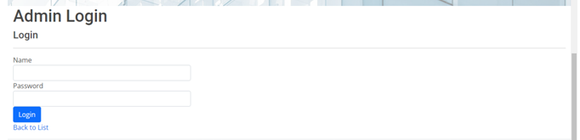



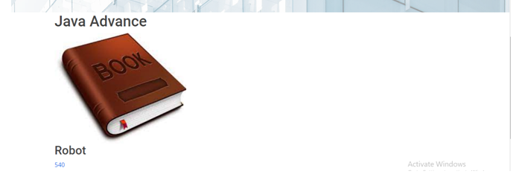



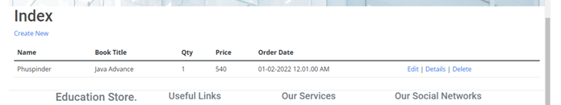

# About colour Schema of the website

Grey text and white background at all screens of the website

# Section 2 – Project development

## Task 4 – Coding [Find in project]

## Task 5- usability testing

|  |  |  |  |  |
| --- | --- | --- | --- | --- |
| User | Task 1  *Admin Login* | Task 2  *Add Book to the Database* | Task 3  *Update Book* | Comments |
| *User 1* | *Login Successful* | *No Validation on Book Name* | *Book Name Updated* | *Very Quick Reponses* |
| User 2 | Worked fine | Book was Added | Description Updated | Design Poor |
| User 3 | Fast Loading Next Page | No Validation | Updated all fields Successfully | Fast Working |

## Task 6 - Meet with your client

Client Meeting:

|  |
| --- |
| Meeting Details |
| * Date and time: 28-Oct-2021 * Location: New Zealand |
| Attendees: Developer Phuspinder Singh and Client Jonas and his Manger Maria |
| Agenda: Discussion of Exam Store Website |
| Discussion (Important Points): To discuss what to include in the site |
| My To Dos (Actions): Firstly I have to make the mock-ups of the application. Then Starting the application after the next meeting. |
| Questions requiring Follow- Up: Discussion of the mock ups |
| Comments: Very impressive about the coding knowledge. |
| Next meeting  Date and Time: 3- Nov-2021 2:00 Pm  Location: New Zealand  Agenda: Showing Rough designs of Website |

**Appendix 3**

**Client Review Form**

My developer’sname: Phuspinder

This form is intended to let you review the communication skills of your developer for this assignment. Your review will partly count towards their final mark. Do not take into account technical skills.

# Grading scale

You must grade your developer for each item listed in the tables below. 1 being the lowest, 5 the highest.

|  |  |  |  |  |
| --- | --- | --- | --- | --- |
| **1** | **2** | **3** | **4** | **5** |
| Strongly disagree | Disagree | Ok | Agree | Strongly agree |

# Review your developer

|  |  |  |
| --- | --- | --- |
| **Item** | **Grade** | **Comment** |
| Communicated clearly and effectively | 5 |  |
| Kept you informed of the progress | 5 |  |
| Met timelines | 4 |  |
| Responded promptly to problems | 3 |  |
| Met overall project objectives | 5 |  |
| Was open to new ideas and suggestions | 3 |  |
| Was easy to work with | 3 |  |

Comments

Provide any extra comments on your developer’s communication skills and professionalism.

Phuspinder is very good in nature and coding style is very professionalism

|  |  |
| --- | --- |
| **Signature: Jonas** | **Date: 18-nov-2021** |
| **Name: Jonas** | **Title: Exam Store** |
| **Contact details (email/Tel):** | |

## Signed by Client

# Section 3– Presentation and reflection

## Task 7- Presentation

Presentation is in Docs Folder

## Task 8 - Software development life cycle stages

This refers to methodology that clarify the process for creating the high quality software’s step by step

* Planning

The initial step of software development is planning and before planning we indentified the problem of business not running offline and planned the structure and database of the website.

* Requirement

After planning, the next step is gathering requirement I gathered requirement and details of all book types that he want to upload

* Software Design and prototyping

After all the things I started coding of software design according to the requirement gathered and completed all the Task

* Software Development

After designing I attached database to the website and started the development of the website

* Testing

Testing the software is very important and I tested it till he turns into a perfection

## Task 9- Project management

I develop this software with project management techniques phase by phase and completed all the stuff very easily

The next step is the planning phase is to go through the website specification,

It was good overall good experience creating is project alone according to client requirement because this was my first experience firstly understanding client requirement and start work according to it and then wait for the approval to continue.

Firstly I face difficulty in making the designs because I was worried about the Client’s Decisions weather he will approve or not as it was my first experience and then after making it I showed designs to client and then approved it and I started working on the designing part.

# Time

I spent about 40-45 days in creating this project design and development part both took equal amount of time in working.

# Difficulties

After that I faced problem to setup database of the project which table to include or exclude and then finally chosen tables according to the client requirement

# Learning’s

Many things which I learned during the project was concept of creating database and tables including foreign key concepts and working professionalism and many more things because satisfying clients requirement is our major concern moreover I also given suggestion of adding Login concept in the website. I suggested client to add Login for the security purpose and he also agreed for the same and was very happy and satisfactory with the work.